Express Apps
Express.js is a lightweight web framework for Node.js used to build web servers and REST APIs easily.
Without Express, Node's built-in HTTP server requires more code.
Main uses
- Routing → /, /about, /users
- REST APIs → GET, POST, PUT, DELETE
- Middleware → authentication, logging, parsing JSON
- Request/response handling → much simpler than raw Node.js HTTP

We can install Express simply by running: npm install express
npm will install Express locally and automatically add it to the dependencies section of package.json.
We will recreate the same server we built earlier, but this time using Express, so we can see how much simpler and easier it is compared to using Node's built-in http module.

Example 1:- We are creating app.js to write our Express code. Here, app.listen(3000) starts the Express server and makes it listen on port 3000. Express handles the underlying server setup for us, so we don't need to manually use http.createServer() and server.listen() like we did with Node's built-in http module.
By default, when no hostname is specified, the server listens on the unspecified address rather than explicitly choosing localhost.

app.get() handles the GET request for a specific route. When we use res.send(), Express automatically determines an appropriate Content-Type based on the type of data being sent and sets the response headers accordingly. It also uses a default 200 status code for a successful response unless we explicitly set another status code. Here, we use res.send() to send HTML content as the response.
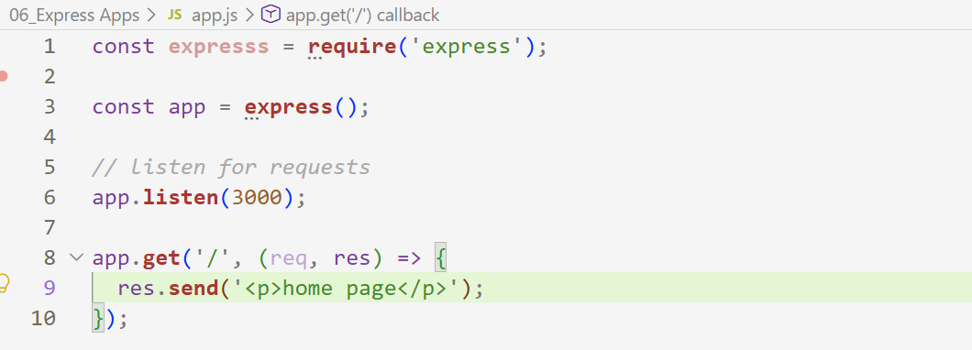
Similar :-
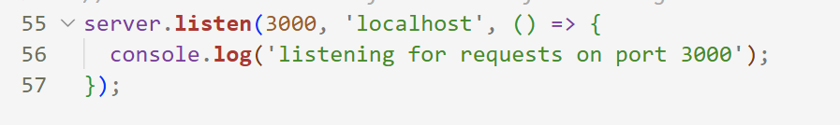
The syntax of .get in express is:- app.get(path, callback);
The syntax of .send in express is:-
app.get("/", (req, res) => {
res.send("Hello World");
});

The syntax of .listen in express is:- res.send(data);

But of course, we want to serve actual HTML pages rather than writing the HTML code directly inside app.js. This keeps our server-side JavaScript separate from our HTML files and makes the project cleaner and easier to maintain.

Example 2:- res.sendFile() requires an absolute file path, but we are providing a relative path. To handle this, we use the root option to specify the base directory. Since we use __dirname, the directory containing app.js becomes the root, and Express can then resolve the relative path such as views/index.html from there. We do the same for about.html.
For the /about-us route, instead of serving another HTML file, we use res.redirect() to redirect the client to /about.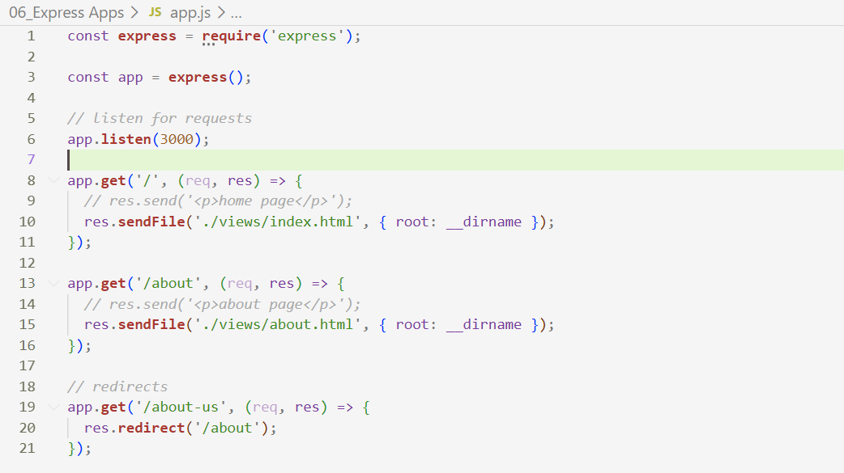
.sendFile() :- res.sendFile(path, options, callback);
Common usage with root :- res.sendFile("views/index.html", { root: __dirname });
.redirect() :- res.redirect(path);

We can't define a separate route for every possible URL if we only want to handle specific routes such as the homepage and /about. For handling requests more generally, we can use the app.use() function. Unlike app.get(), which is scoped to a specific path and HTTP method, app.use() can be used as middleware and runs for every request that reaches it, unless a specific path is provided.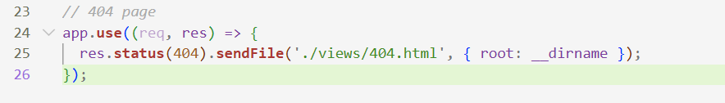
We add this app.use() middleware at the end of our route definitions. This is because we want the existing routes such as /, /about, and /about-us to be handled first. If the requested URL does not match any of those routes, the request reaches this middleware, where we can serve the 404.html page.
We also use res.status() to set the HTTP status code of the response before sending it to the browser.

